**Naming and Tagging a Containers and Images**



Naming a Container



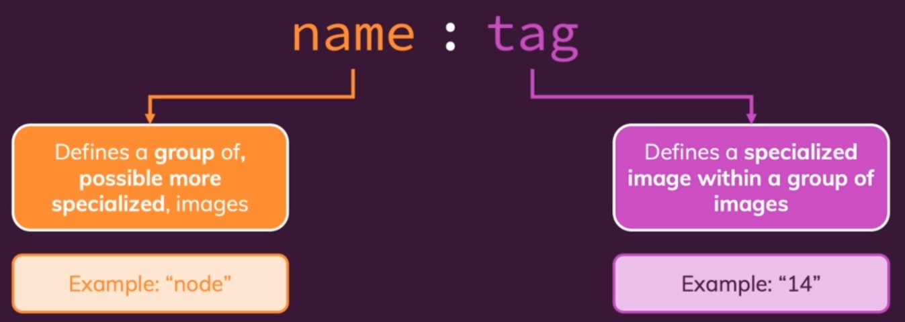



we could Docker build our Dockerfile in this directory but we can add dash T in front of the dot and then specify our name tag combination.





